# **Create a Virtual Environment and Django Project**

## Windows <**Python 3.11.7 and PyCharm**> Edition

1. Begin by checking the version of Python you are using.

1. Create a workspace folder using: “mkdir CS3300 | cd CS3300”
2. Create a portfolio folder; then, create a virtual environment inside said folder.

1. Activate virtual environment with: “djvenv\bin\activate.bat”
2. Begin installing Django in the virtual environment.

1. Update pip using the given command: “…\python.exe -m pip install --upgrade pip”.
2. Create a Django project using: “py -m django startproject django_project”.
3. For ease of use, reorder the directory structure to match the one shown below.

1. Run the server and ignore and migration warnings that appear.

1. See if the installation worked by going to: <http://localhost:8000/>
2. Open two more terminal windows; activate the virtual environment in one.

1. Check all installed Python packages using either pip’s “list” or “freeze” commands.

1. Create a requirements file containing what packages are installed.

1. In PyCharm (IDE), go to ‘File -> Open Folder’ and select the folder/repository containing the newly-created Django project.

# **Create a Local Git and Github Repository**

1. Create a private GitHub repository (separate from the team’s repository).
2. Initialize your local directory/folder; create your “.gitignore” file.

1. Commit changes and link your local repository to the GitHub repository.

1. Once finished, push the changes to the main branch.

# **Create a Portfolio Application**

1. Create and switch to a branch called “sprint01”.

1. Activate the virtual environment.
2. Create an application named “portfolio_app”.

1. In PyCharm (IDE), go to ‘File -> Open Folder’ and select the folder/repository containing the newly-created portfolio application.
2. In PyCharm (IDE), open the django_project’s setting.py file.
3. Add the app to the “INSTALLED_APPS” list; append support for authenticating users.

# **Define a URI Path and View**

1. In PyCharm (IDE), go to ‘File -> Open Folder’ and select the folder/repository containing the newly-created portfolio application.
2. In PyCharm (IDE), open the django_project’s urls.py file.
3. Add a path below the admin path to include the portfolio_app urls.py specific URLs.

1. Update the portfolio_app/views.py by defining the following homepage view.

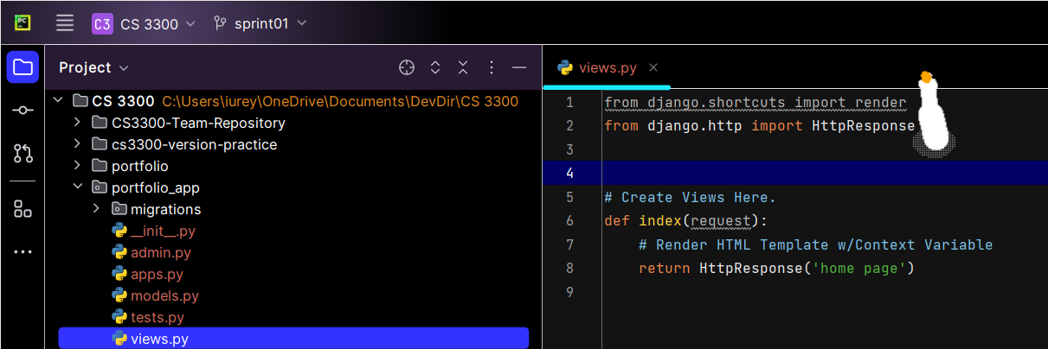

1. Create a urls.py file in portfolio_app that contains a path to the defined view.

1. Run the server and ignore and migration warnings that appear.

1. See if the updated view worked by going to: <http://127.0.0.1:8000>
2. Update the portfolio_app/views.py by defining a new homepage view.

# **Add a Static File**

1. In PyCharm (IDE), go to ‘File -> Open Folder’ and select “portfolio”.
2. Create a directory called “static”; inside there, create another called "images”.
3. Add the provided image to portfolio/static/images: [UCCS LOGO](https://brand.uccs.edu/sites/g/files/kjihxj1416/files/inline-images/uccs-signature-email.gif).

1. Update the django_project/settings.py to find the newly-created static file.

1. Update the django_project/settings.py to tell Django how to locate the folder.

1. Update the portfolio_app/base_template.html (top of file) format.

1. Add the provided logo to the portfolio_app/base_template.html file.



1. See your displayed logo by going to: <http://127.0.0.1:8000>
2. Merge the “sprint 01” branch with the main branch; tag the code as “GE02”.

